Final Project: CO2 Emissions

By Jesse Verra

Here we try to answer these 3 questions:

1. What is the biggest predictor of a large CO2 output per capita of a country?
2. What countries are making the biggest strides in decreasing CO2 output?
3. Witch non-fossil fuel energy technology will have the best price in the future?

I will use this Google Colab notebook for my code: <https://colab.research.google.com/drive/1QIin51f2Tb5AWxolkxuh5s0LY4ygU39_>

In this repository I will be showing more data than is represented here.

1. What is the biggest predictor of a large CO2 output per capita of a country?

When looking for a predictor of CO2 you can look at a load of different things. From energy demand to concrete usage for building. The strongest predictor for CO2 per capita turned out to be GDP per capita.

I used this dataset for the graph below: <https://ourworldindata.org/grapher/co2-emissions-vs-gdp> compared

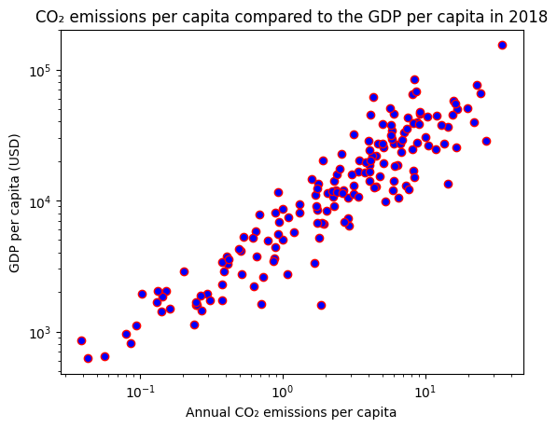

We can clearly see the correlation between GDP per capita and Annual CO2 emissions per capita.

Qatar is the biggest polluter per capita and also the biggest GDP

I found two other corelating variables, but both are not as strong.

They can be found in the notebook.

1. Biggest strides in decreasing CO2 output.

We want to know what country is doing the best, and the worst at decreasing CO2 output.

I will be using this dataset to see who is growing and shrinking their CO2 output: <https://ourworldindata.org/grapher/co2-emissions-vs-gdp>

This is the same dataset as used in the first part.

There is no complete data from 2019 onwards, so I will take a look at 2013 thru 2018.

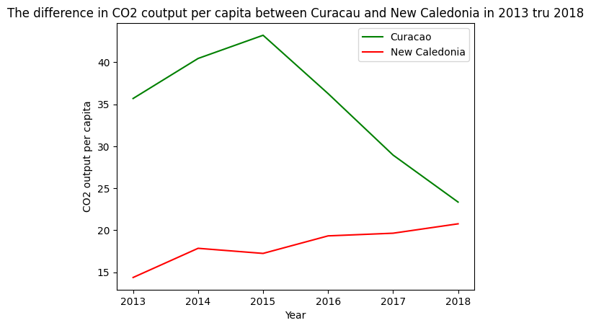

We can see Curacao is doing the best over this time period, by lowering the output by 12.34 ton per capita.

New Caledonia is doing the worst by increasing output by 6.39 ton per capita.

To see the top 5 and bottom 5 please refer to the notebook.

1. Best future price for non-fossil fuel energy.

We want to see what non-fossil fuel energy source will be the most cost effective in the future. We will use linear regression to see what energy source is lowering in price the most.

I will be using this dataset for this part: <https://ourworldindata.org/grapher/levelized-cost-of-energy>

Here we see that solar photovoltaic prices are going down the fastest with a slope of

-0.028275 dollars per kWh per year.

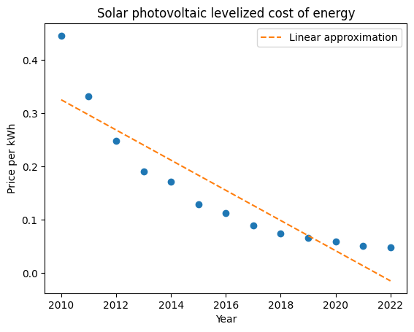

We can see the price quickly going down from 2010 onward.

To see the other energy sources please check out the notebook.